## **IDEAS**

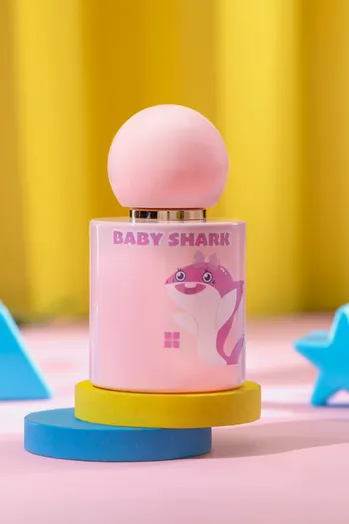

**Baby Shark Pink Perfume**

**PKR 1,490.00**

**Baby Shark Pink is the perfect choice for kids as it embodies fun and innocence. Top notes of this playful spray feature fruity pear and floral rose aromas. The fragrance lasts all day as the little ones play.**

**Size: 30ml Bottle**